'Parents Plus' and 'Working Things Out' Programmes

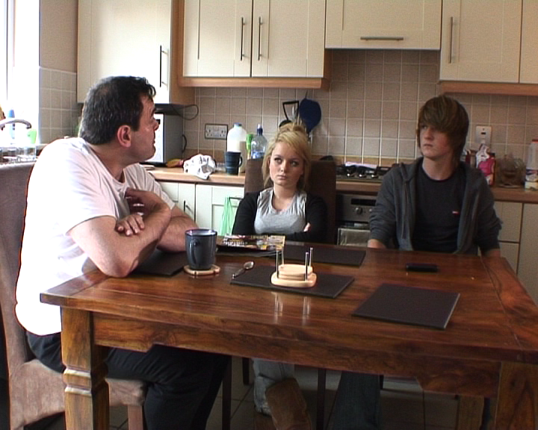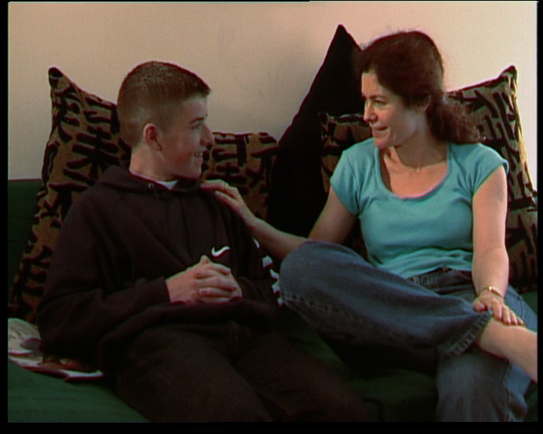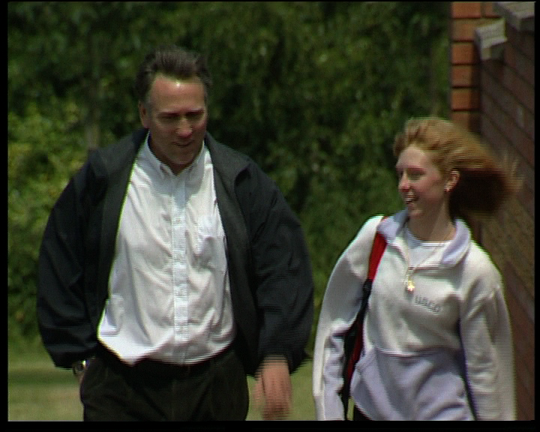

Newpark School is very excited to be running a programme which focuses on the tricky job of parenting teenagers!

Parents are really important in helping their teenagers develop and grow up as responsible adults. Yet parenting can sometimes be a difficult job and everyone needs support and help.

The Parents Plus programme hopes to help you with:
- Getting to know and connecting with your teenager
- Communicating effectively
- Negotiating rules and boundaries
- Teaching teenagers responsibility
- Managing conflict
- Solving problems together

The course does not propose to find magic answers but hopes to help parents to gain the support of other parents and to find down-to-earth solutions for difficult situations. The focus of the course is positive and aims to build on your strengths as a parent and what you are already doing right.

The Working Things Out programme for adolescents hopes to directly help teenagers with:
- Solving problems and making good decisions
- Handling the ups and downs of friendships
- Dealing with bullying
- Managing anger, anxiety and worry
- Coping with stress
- Dealing with relationships at home and at school

This is a great new course developed in Ireland by John Sharry (you may know his Irish Times column).

- The Working Things Out course for teenagers will be run during the school day for a double period every Thursday over a six week period.
- The Parents Plus programme will run on a Wednesday morning in Newpark from 11.30 to 1.30pm. The course begins on the 24th January 2017, and will run for six weeks.

Who should attend the parenting programme:
The course is open to all parents whose children are in Second Year in Newpark. Where possible we recommend that both parents attend the course as we have found this helps the child the most. If you are parenting alone please feel free to bring along another supportive family member. Your child will also be attending the Working Things Out programme in Newpark.

Practical details:
The parenting course consists of six parent group meetings. Please contact the school if you are interested and please note places are very limited so register as soon as possible. Make contact via email to: parentsplus@newparkschool.ie or contact the school front office. For more information you can also visit: www.parentsplus.ie

Parent Plus Facilitators: Eoin Norton & Jenny Crampton Working Things Out Facilitators: Emma Mullock & Kevin Kirwan

