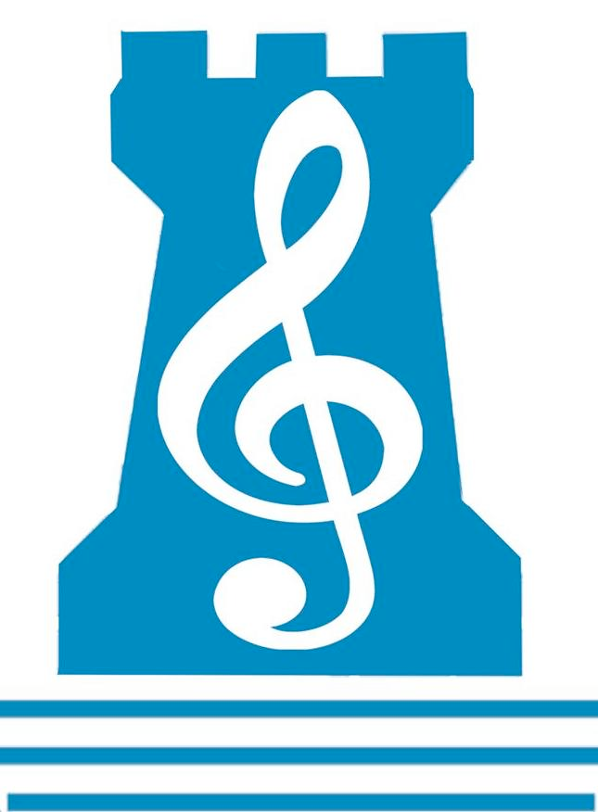
Newpark Music Department
First Year Revision Checklist 2018

Q1: ORCHESTRA

- Instruments
- Families of Instruments

Q2: TREBLE AND BASS CLEF LETTER NAMES
- Treble Clef – Lines and Spaces
(Elephants Go Backwards Down Fireescapes // FACE)

- Bass Clef – Lines and Spaces
(Good Bulls Don’t Feel Angry // All Cows Eat Grass)

- Be able to identify letter names from notes given, AND to be able to put notes on the stave, when given the letter names

Q3: RHYMIC COMPOSITION
- Compose a 4-bar rhythm in both 4/4 and 3/4 TIME SIGNATURES

Q3: STICK//SOLFA//STAVE
- Transcribe GIVEN Rhythm and Solfa into the Stave
- Create your own rhythm and Solfa and transcribe into the Stave
- KEY SIGNATURES :
C major, G major, D major, F major, B♭ major,
- SOLFA USED : doh, ray, me, soh, lah

Q4: AURAL SKILLS
- You will hear a piece of music that you may have not heard before and will answer questions about it.

PERFORMING – Option A will be on Thursday 24th May
– Option B will be on Tuesday 22nd May
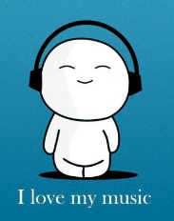
- ONE group piece in your Band
- ONE solo piece on your chosen instrument

