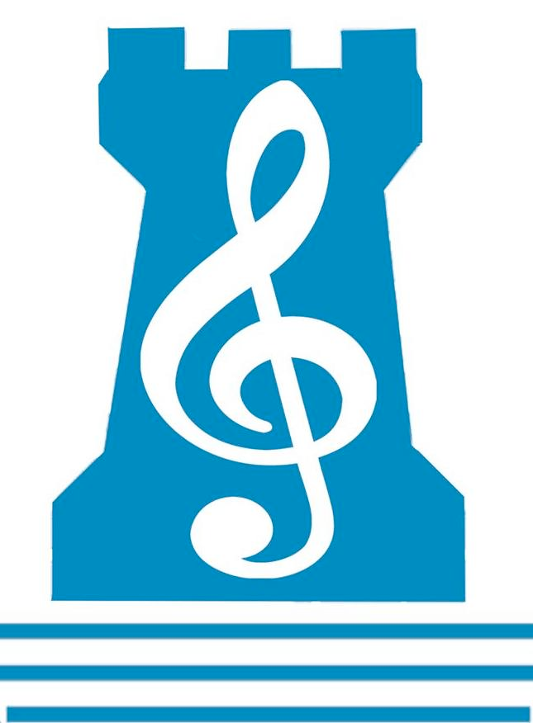
Newpark Music Department
Second Year Revision Checklist 2018

End-of-Year Music Exam will comprise THREE sections in total:
75%= Listening & Composing exam
20% = Practical Exam
5%= Continuous Assessment: Copy & Manuscript
_____________________________________________________________________________________
Q1: SET SONGS

- Click Go The Shears
- Can’t Help Lovin’ Dat Man
- Yesterday
- Wanderer’s Night Song
- Evening Prayer

Q2: SET WORKS
- Peer Gynt Suite : Morning / Anitra’s Dance / In the Hall of the Mountain King
- Hoedown

Q3: IRISH MUSIC

- Dances
- Traditional Instruments

- Performers

Q4: DICTATION- 4 Bars
- Fill in the missing Melody & Rhythm – Stick/Solfa/Staff

Q5: GENERAL LISTENING
- Answer aural skills questions on an unheard piece of music

Q6: TRIADS
- Key Signatures C, F, G, D & Bb / Chord Banks / Bass Clef / Major&Minor Chords
.
Q7: MELODY WRITING
- Given 2 bars of a Melody with Rhythm- Continue with another 2 bars.

Q8: BACKING CHORDS
- Chord Banks in all keys / Backing Chord Question

Q9: GLOSSARY (Literacy & Numeracy)
- All terms studied since 1st Year

Q10:GENERAL STUDY
- Write about TWO Musical Features of your Chosen Study

PERFORMING- Exam will be a total of 10 minutes in length
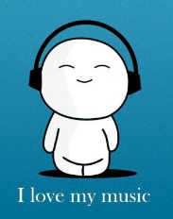
- TWO group band pieces OR TWO solo pieces on your chosen instrument
- Unprepared Test: Clap back a 4-bar Rhythm played 3 times

