**LC OL Maths Exam Revision List Summer Exam 2018**

**Topics Chapters**

Algebra 1 Chapter 1Page 1 - 22

Algebra 2 Chapter 2Page 25 – 46

Statistics

Collecting Data Chapter 4 Page 77 – 95

Mean – Median – Mode Chapter 8 Page 208 – 232

Representing Data Chapter 13 Page 353 – 388

Probability Chapter 6 Page 137 -181

Coordinate Geometry of the line Chapter 3 page 49 - 73

Coordinate Geometry of the circle Chapter 12 page 336 – 349

Geometry 1 Chapter 11 page 302 – 332

Geometry 2 Chapter 15 page 430 – 448

Complex Numbers Chapter 7 page 186 – 205

Arithmetic (whatever has been covered) Chapter 5

1.  when x = 1

2.  when x=-3

3. Write  in its simplest terms.  
  
4. Write in its simplest terms.

5. Solve for x: , 

6. Solve for x: , 

7. Solve for x and y: 

8. Solve for x: 

9. Solve for x: 

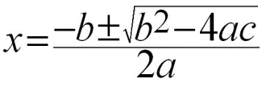

10. Solve for x: 

11. Solve for x: 

12. Solve for x

  

13.



14



15. If write p in terms of q.

16. Forming an Equation When Given the Roots

1. -2, -4
2. 1,-6
3. 4, 5
4. , 8

17. Evaluate the following: $\sqrt{16}$

Express these surds in their simplest forms:

18. Equations Involving Surds

1. Rearrange the equation so that the part with the is on its own.
2. Square both sides to remove the .
3. Solve for x.

Solve the following equations and check your answers:

19. $\sqrt{x+5}=4$

$\sqrt{4x+5}$ = 5

$\sqrt{2x-1}$ = $\sqrt{x+8}$

Statistics

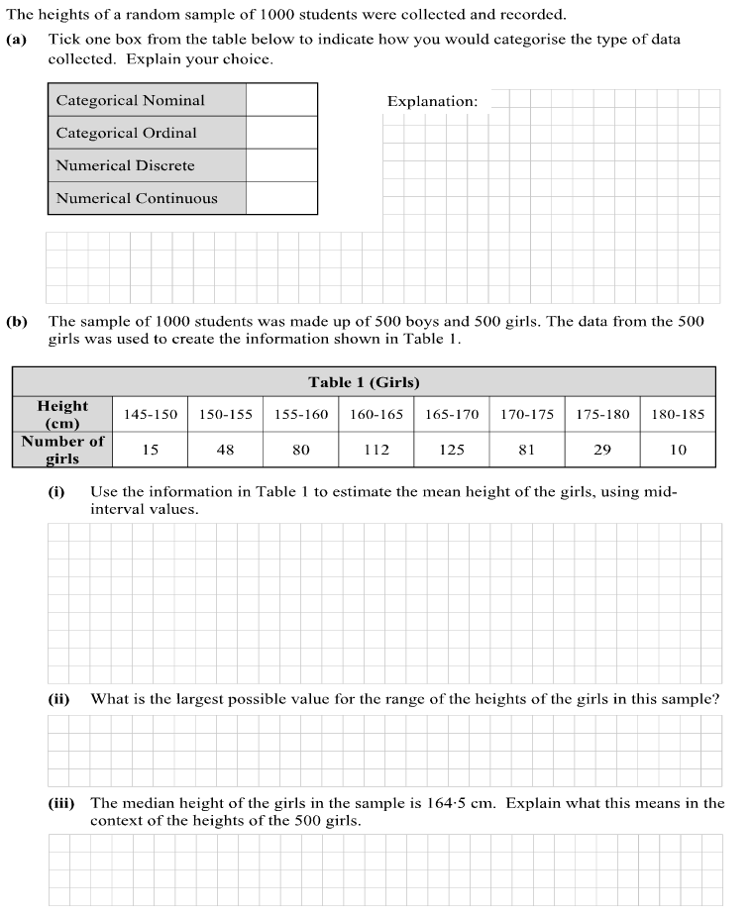

Q1 A Set of results is laid out in a grouped frequency table as shown below.

|  |  |  |  |  |  |
| --- | --- | --- | --- | --- | --- |
| x | 4 – 6 | 6 – 8 | 8 – 10 | 10 – 12 | 12 – 14 |
| f | 2 | 4 | 8 | 5 | 1 |

(i) What is the modal class? ____________

(ii) Find the class in which the median appears.

|  |  |  |  |  |  |  |  |  |  |  |  |  |  |  |  |  |  |  |  |  |  |  |  |  |  |  |  |  |  |  |  |  |  |  |  |
| --- | --- | --- | --- | --- | --- | --- | --- | --- | --- | --- | --- | --- | --- | --- | --- | --- | --- | --- | --- | --- | --- | --- | --- | --- | --- | --- | --- | --- | --- | --- | --- | --- | --- | --- | --- |
|  |  |  |  |  |  |  |  |  |  |  |  |  |  |  |  |  |  |  |  |  |  |  |  |  |  |  |  |  |  |  |  |  |  |  |  |
|  |  |  |  |  |  |  |  |  |  |  |  |  |  |  |  |  |  |  |  |  |  |  |  |  |  |  |  |  |  |  |  |  |  |  |  |
|  |  |  |  |  |  |  |  |  |  |  |  |  |  |  |  |  |  |  |  |  |  |  |  |  |  |  |  |  |  |  |  |  |  |  |  |
|  |  |  |  |  |  |  |  |  |  |  |  |  |  |  |  |  |  |  |  |  |  |  |  |  |  |  |  |  |  |  |  |  |  |  |  |
|  |  |  |  |  |  |  |  |  |  |  |  |  |  |  |  |  |  |  |  |  |  |  |  |  |  |  |  |  |  |  |  |  |  |  |  |
|  |  |  |  |  |  |  |  |  |  |  |  |  |  |  |  |  |  |  |  |  |  |  |  |  |  |  |  |  |  |  |  |  |  |  |  |
|  |  |  |  |  |  |  |  |  |  |  |  |  |  |  |  |  |  |  |  |  |  |  |  |  |  |  |  |  |  |  |  |  |  |  |  |

(iii) Calculate the mean

|  |  |  |  |  |  |  |  |  |  |  |  |  |  |  |  |  |  |  |  |  |  |  |  |  |  |  |  |  |  |  |  |  |  |  |  |
| --- | --- | --- | --- | --- | --- | --- | --- | --- | --- | --- | --- | --- | --- | --- | --- | --- | --- | --- | --- | --- | --- | --- | --- | --- | --- | --- | --- | --- | --- | --- | --- | --- | --- | --- | --- |
|  |  |  |  |  |  |  |  |  |  |  |  |  |  |  |  |  |  |  |  |  |  |  |  |  |  |  |  |  |  |  |  |  |  |  |  |
|  |  |  |  |  |  |  |  |  |  |  |  |  |  |  |  |  |  |  |  |  |  |  |  |  |  |  |  |  |  |  |  |  |  |  |  |
|  |  |  |  |  |  |  |  |  |  |  |  |  |  |  |  |  |  |  |  |  |  |  |  |  |  |  |  |  |  |  |  |  |  |  |  |
|  |  |  |  |  |  |  |  |  |  |  |  |  |  |  |  |  |  |  |  |  |  |  |  |  |  |  |  |  |  |  |  |  |  |  |  |
|  |  |  |  |  |  |  |  |  |  |  |  |  |  |  |  |  |  |  |  |  |  |  |  |  |  |  |  |  |  |  |  |  |  |  |  |
|  |  |  |  |  |  |  |  |  |  |  |  |  |  |  |  |  |  |  |  |  |  |  |  |  |  |  |  |  |  |  |  |  |  |  |  |
|  |  |  |  |  |  |  |  |  |  |  |  |  |  |  |  |  |  |  |  |  |  |  |  |  |  |  |  |  |  |  |  |  |  |  |  |

(iv) Find the range

|  |  |  |  |  |  |  |  |  |  |  |  |  |  |  |  |  |  |  |  |  |  |  |  |  |  |  |  |  |  |  |  |  |  |  |  |
| --- | --- | --- | --- | --- | --- | --- | --- | --- | --- | --- | --- | --- | --- | --- | --- | --- | --- | --- | --- | --- | --- | --- | --- | --- | --- | --- | --- | --- | --- | --- | --- | --- | --- | --- | --- |
|  |  |  |  |  |  |  |  |  |  |  |  |  |  |  |  |  |  |  |  |  |  |  |  |  |  |  |  |  |  |  |  |  |  |  |  |
|  |  |  |  |  |  |  |  |  |  |  |  |  |  |  |  |  |  |  |  |  |  |  |  |  |  |  |  |  |  |  |  |  |  |  |  |
|  |  |  |  |  |  |  |  |  |  |  |  |  |  |  |  |  |  |  |  |  |  |  |  |  |  |  |  |  |  |  |  |  |  |  |  |
|  |  |  |  |  |  |  |  |  |  |  |  |  |  |  |  |  |  |  |  |  |  |  |  |  |  |  |  |  |  |  |  |  |  |  |  |
|  |  |  |  |  |  |  |  |  |  |  |  |  |  |  |  |  |  |  |  |  |  |  |  |  |  |  |  |  |  |  |  |  |  |  |  |
|  |  |  |  |  |  |  |  |  |  |  |  |  |  |  |  |  |  |  |  |  |  |  |  |  |  |  |  |  |  |  |  |  |  |  |  |
|  |  |  |  |  |  |  |  |  |  |  |  |  |  |  |  |  |  |  |  |  |  |  |  |  |  |  |  |  |  |  |  |  |  |  |  |

Q2 Consider the following data; 40, 48, 50, 52, 56, 58, 60, 65, 68, 70

(a) Find the mean of the data

|  |  |  |  |  |  |  |  |  |  |  |  |  |  |  |  |  |  |  |  |  |  |  |  |  |  |  |  |  |  |  |  |  |  |  |  |
| --- | --- | --- | --- | --- | --- | --- | --- | --- | --- | --- | --- | --- | --- | --- | --- | --- | --- | --- | --- | --- | --- | --- | --- | --- | --- | --- | --- | --- | --- | --- | --- | --- | --- | --- | --- |
|  |  |  |  |  |  |  |  |  |  |  |  |  |  |  |  |  |  |  |  |  |  |  |  |  |  |  |  |  |  |  |  |  |  |  |  |
|  |  |  |  |  |  |  |  |  |  |  |  |  |  |  |  |  |  |  |  |  |  |  |  |  |  |  |  |  |  |  |  |  |  |  |  |
|  |  |  |  |  |  |  |  |  |  |  |  |  |  |  |  |  |  |  |  |  |  |  |  |  |  |  |  |  |  |  |  |  |  |  |  |
|  |  |  |  |  |  |  |  |  |  |  |  |  |  |  |  |  |  |  |  |  |  |  |  |  |  |  |  |  |  |  |  |  |  |  |  |
|  |  |  |  |  |  |  |  |  |  |  |  |  |  |  |  |  |  |  |  |  |  |  |  |  |  |  |  |  |  |  |  |  |  |  |  |
|  |  |  |  |  |  |  |  |  |  |  |  |  |  |  |  |  |  |  |  |  |  |  |  |  |  |  |  |  |  |  |  |  |  |  |  |
|  |  |  |  |  |  |  |  |  |  |  |  |  |  |  |  |  |  |  |  |  |  |  |  |  |  |  |  |  |  |  |  |  |  |  |  |

(b) Find the standard deviation of the data.

|  |  |  |  |  |  |  |  |  |  |  |  |  |  |  |  |  |  |  |  |  |  |  |  |  |  |  |  |  |  |  |  |  |  |  |  |
| --- | --- | --- | --- | --- | --- | --- | --- | --- | --- | --- | --- | --- | --- | --- | --- | --- | --- | --- | --- | --- | --- | --- | --- | --- | --- | --- | --- | --- | --- | --- | --- | --- | --- | --- | --- |
|  |  |  |  |  |  |  |  |  |  |  |  |  |  |  |  |  |  |  |  |  |  |  |  |  |  |  |  |  |  |  |  |  |  |  |  |
|  |  |  |  |  |  |  |  |  |  |  |  |  |  |  |  |  |  |  |  |  |  |  |  |  |  |  |  |  |  |  |  |  |  |  |  |
|  |  |  |  |  |  |  |  |  |  |  |  |  |  |  |  |  |  |  |  |  |  |  |  |  |  |  |  |  |  |  |  |  |  |  |  |
|  |  |  |  |  |  |  |  |  |  |  |  |  |  |  |  |  |  |  |  |  |  |  |  |  |  |  |  |  |  |  |  |  |  |  |  |
|  |  |  |  |  |  |  |  |  |  |  |  |  |  |  |  |  |  |  |  |  |  |  |  |  |  |  |  |  |  |  |  |  |  |  |  |
|  |  |  |  |  |  |  |  |  |  |  |  |  |  |  |  |  |  |  |  |  |  |  |  |  |  |  |  |  |  |  |  |  |  |  |  |
|  |  |  |  |  |  |  |  |  |  |  |  |  |  |  |  |  |  |  |  |  |  |  |  |  |  |  |  |  |  |  |  |  |  |  |  |

(c) Consider the data 48, 48, 52, 57, 59, 61, 63, 63, 98, 100

Find the median of the data.

|  |  |  |  |  |  |  |  |  |  |  |  |  |  |  |  |  |  |  |  |  |  |  |  |  |  |  |  |  |  |  |  |  |  |  |  |
| --- | --- | --- | --- | --- | --- | --- | --- | --- | --- | --- | --- | --- | --- | --- | --- | --- | --- | --- | --- | --- | --- | --- | --- | --- | --- | --- | --- | --- | --- | --- | --- | --- | --- | --- | --- |
|  |  |  |  |  |  |  |  |  |  |  |  |  |  |  |  |  |  |  |  |  |  |  |  |  |  |  |  |  |  |  |  |  |  |  |  |
|  |  |  |  |  |  |  |  |  |  |  |  |  |  |  |  |  |  |  |  |  |  |  |  |  |  |  |  |  |  |  |  |  |  |  |  |
|  |  |  |  |  |  |  |  |  |  |  |  |  |  |  |  |  |  |  |  |  |  |  |  |  |  |  |  |  |  |  |  |  |  |  |  |
|  |  |  |  |  |  |  |  |  |  |  |  |  |  |  |  |  |  |  |  |  |  |  |  |  |  |  |  |  |  |  |  |  |  |  |  |
|  |  |  |  |  |  |  |  |  |  |  |  |  |  |  |  |  |  |  |  |  |  |  |  |  |  |  |  |  |  |  |  |  |  |  |  |
|  |  |  |  |  |  |  |  |  |  |  |  |  |  |  |  |  |  |  |  |  |  |  |  |  |  |  |  |  |  |  |  |  |  |  |  |
|  |  |  |  |  |  |  |  |  |  |  |  |  |  |  |  |  |  |  |  |  |  |  |  |  |  |  |  |  |  |  |  |  |  |  |  |

(d) Find the interquartile range of the data

|  |  |  |  |  |  |  |  |  |  |  |  |  |  |  |  |  |  |  |  |  |  |  |  |  |  |  |  |  |  |  |  |  |  |  |  |
| --- | --- | --- | --- | --- | --- | --- | --- | --- | --- | --- | --- | --- | --- | --- | --- | --- | --- | --- | --- | --- | --- | --- | --- | --- | --- | --- | --- | --- | --- | --- | --- | --- | --- | --- | --- |
|  |  |  |  |  |  |  |  |  |  |  |  |  |  |  |  |  |  |  |  |  |  |  |  |  |  |  |  |  |  |  |  |  |  |  |  |
|  |  |  |  |  |  |  |  |  |  |  |  |  |  |  |  |  |  |  |  |  |  |  |  |  |  |  |  |  |  |  |  |  |  |  |  |
|  |  |  |  |  |  |  |  |  |  |  |  |  |  |  |  |  |  |  |  |  |  |  |  |  |  |  |  |  |  |  |  |  |  |  |  |
|  |  |  |  |  |  |  |  |  |  |  |  |  |  |  |  |  |  |  |  |  |  |  |  |  |  |  |  |  |  |  |  |  |  |  |  |
|  |  |  |  |  |  |  |  |  |  |  |  |  |  |  |  |  |  |  |  |  |  |  |  |  |  |  |  |  |  |  |  |  |  |  |  |
|  |  |  |  |  |  |  |  |  |  |  |  |  |  |  |  |  |  |  |  |  |  |  |  |  |  |  |  |  |  |  |  |  |  |  |  |
|  |  |  |  |  |  |  |  |  |  |  |  |  |  |  |  |  |  |  |  |  |  |  |  |  |  |  |  |  |  |  |  |  |  |  |  |

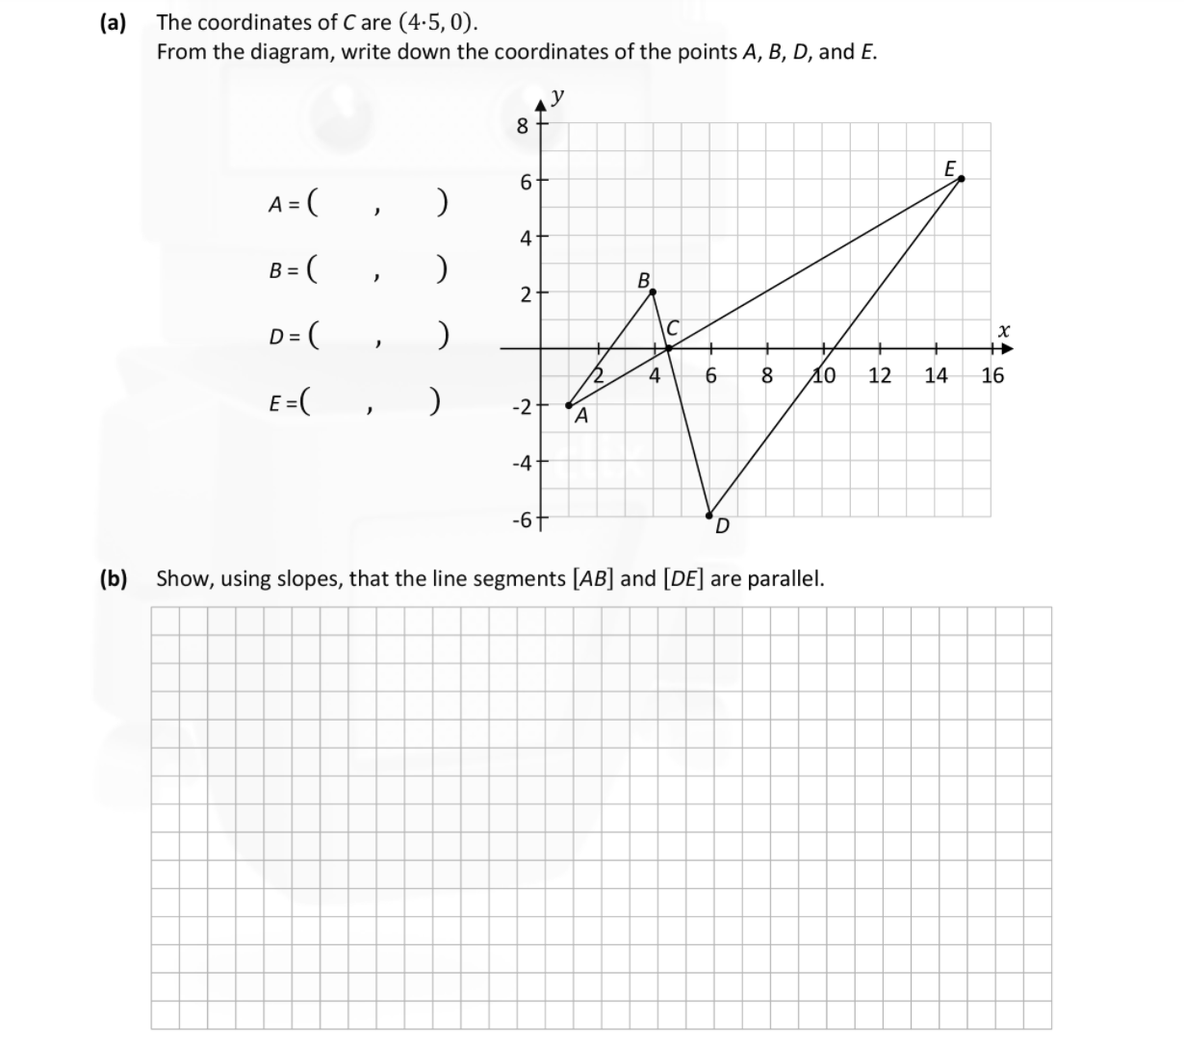

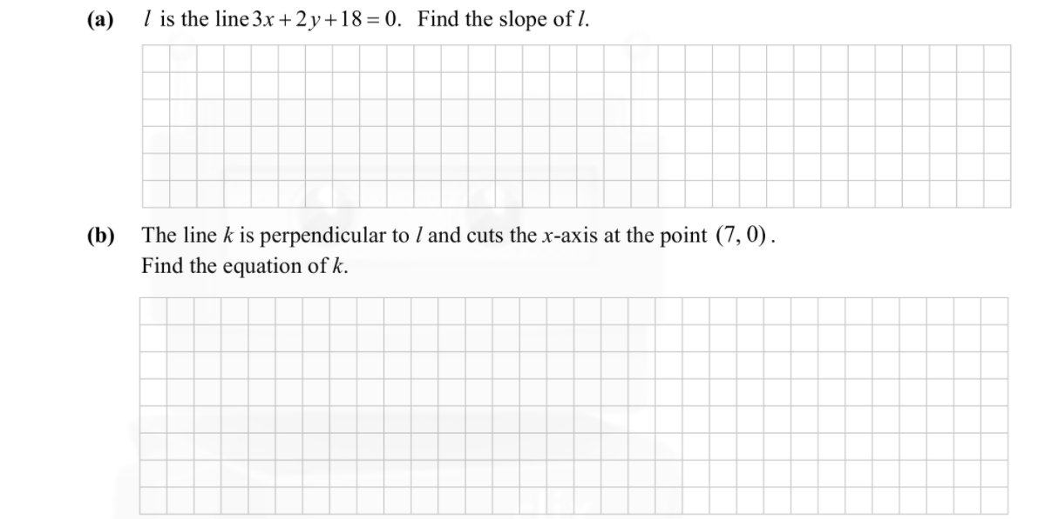

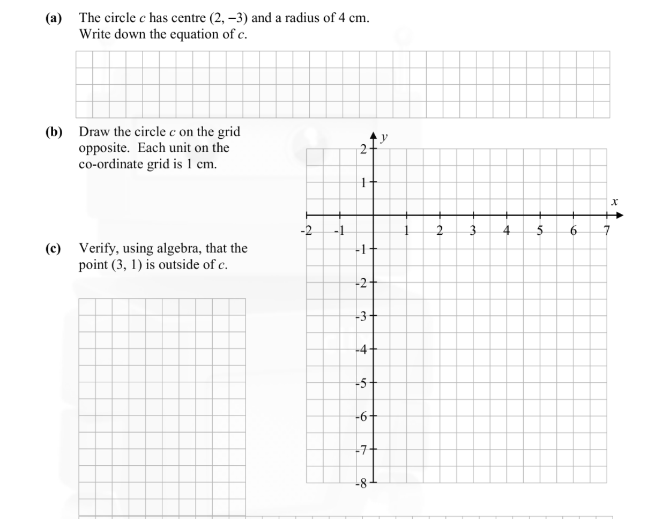

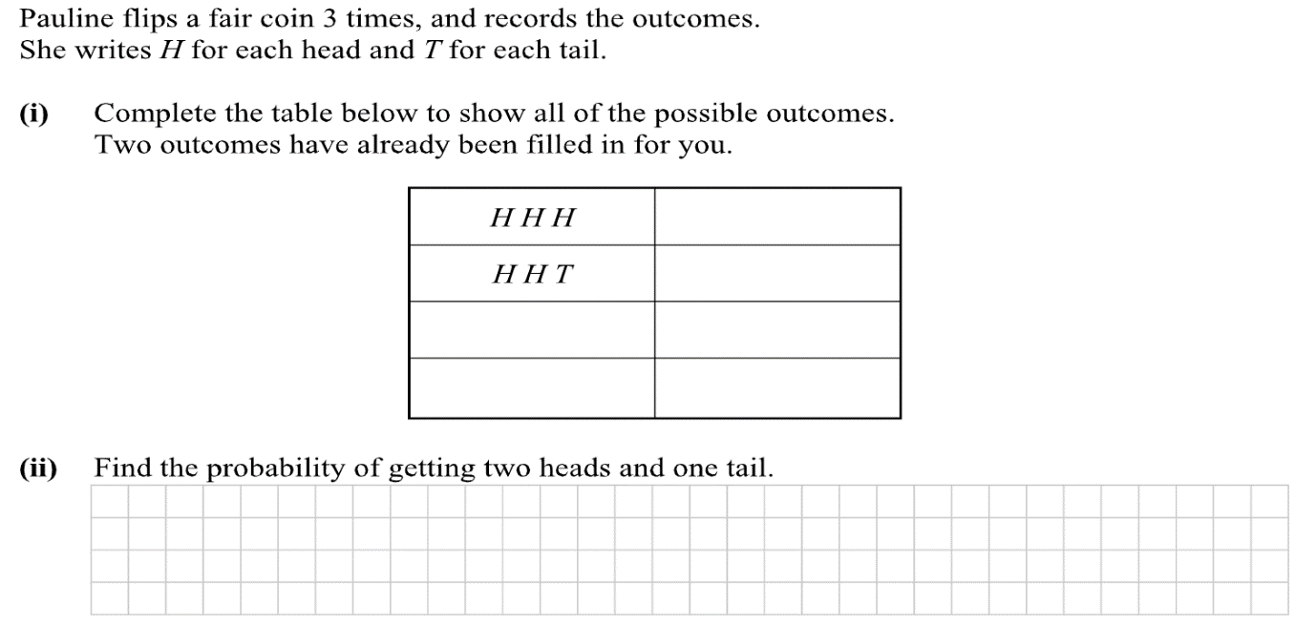

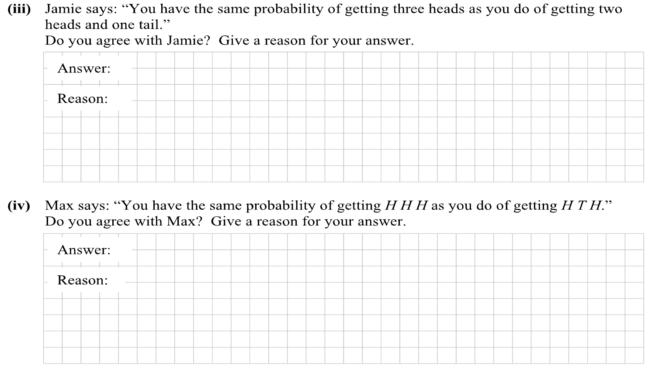

**Q2.** Define the following terms:

Fundamental Principle of Counting:

**_______________________________________________________________________________________________________________________________________________________________________________________________­­­_**

**Bernoulli trial:**

**________________________________________________________________________________________________________________________________________________________________________________________________**

**Q3.**

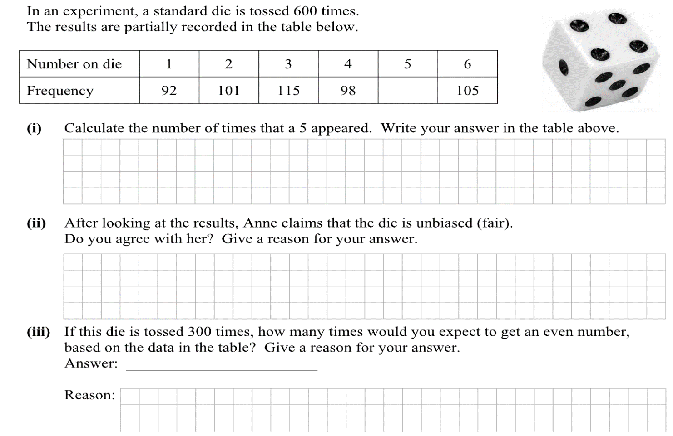

Q4

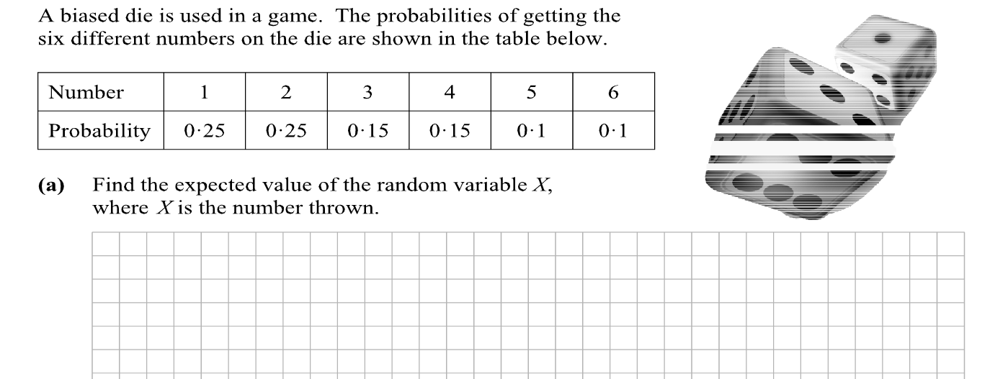

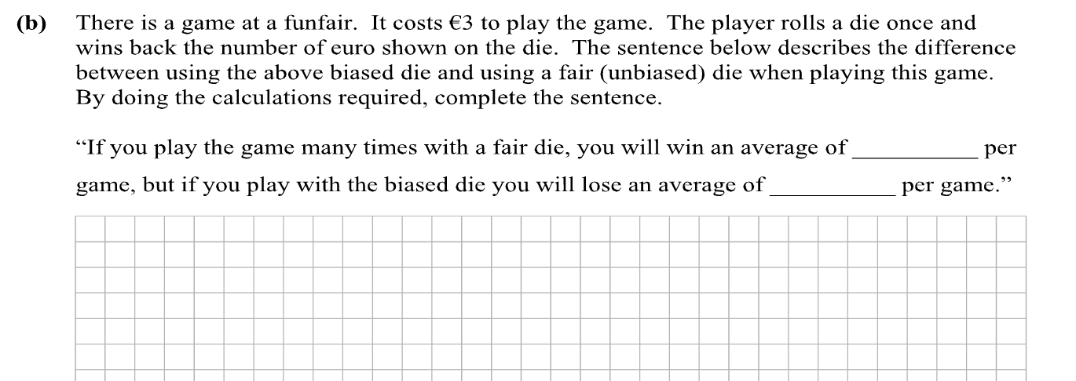

Q5

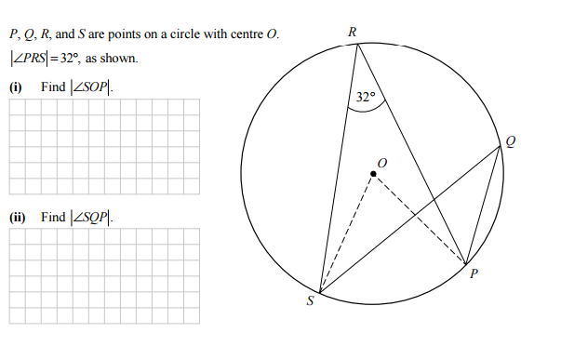

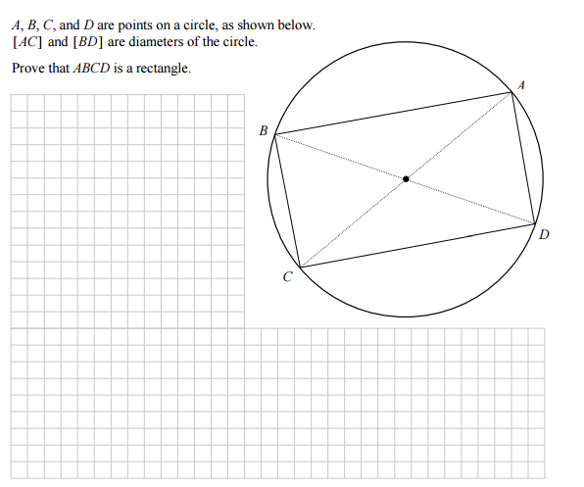

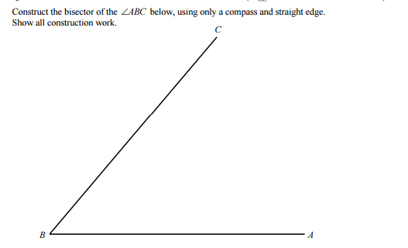

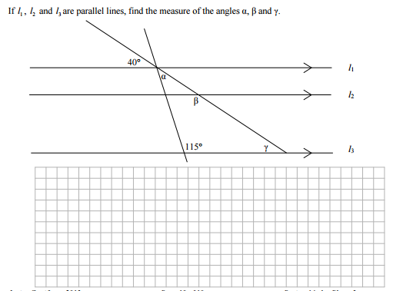

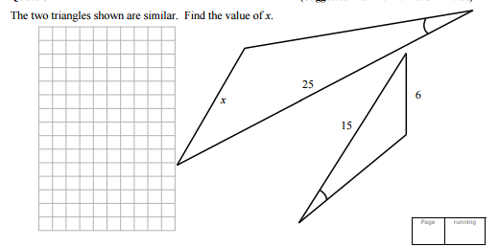

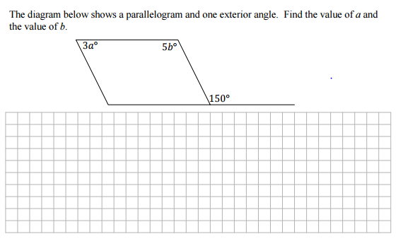

Constructions

