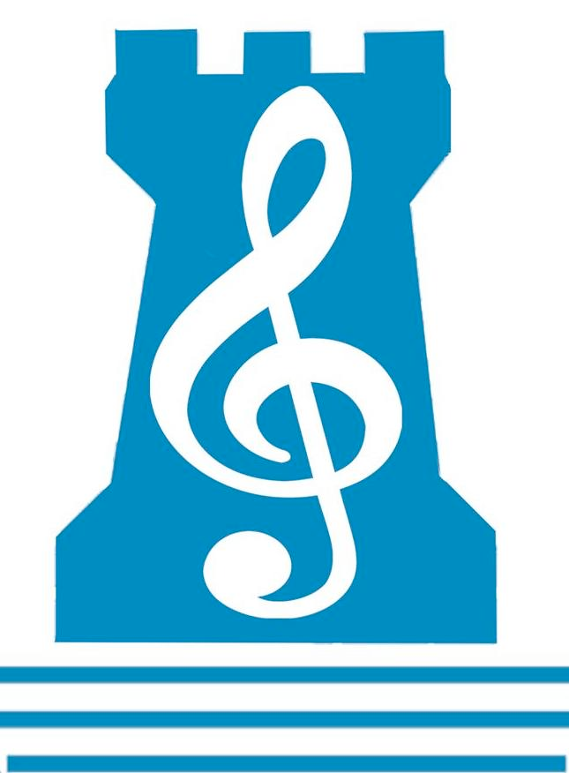
Newpark Music Department
FIFTH Year Revision Checklist 2018

End-of-Year Music Exam will comprise THREE sections in total:
75%= Listening & Composing exam
25% = Practical Exam
_____________________________________________________________________________________

Q1: TCHAIKOVSKY
- ALL MOVEMENTS
- Identify THEMES AND MOTIFS– Friar Laurence, Strife Theme, Love Theme
- Tracing the THEMES – Be able to identify which movement is heard through the theme being played
- Features, Instrumentation, Accompaniment

Q2: BACH
- ALL MOVEMENTS
- Compare and Contrast the CHORUS (Mvt1) and CHORALE (Mvt7)
- Compare and Contrasting the Arias (with each other) and the Recitatives (with each other)
- Be able to describe the différence between Arias and Recitatives.

Q3: IRISH MUSIC
- Listening Questions :
Instruments, Dances – time signatures and examples of rhythm
- Possible Essay Questions :
- Development of Irish Music in the 20th Century,
- The Influence of Irish Music in North America,
- Harping Tradition/Belfast Harp Festival/Edward Bunting
- Composers/Performers of Irish Music
- Fusion

Q4: AURAL SKILLS
- Answer questions on an UNHEARD piece of music

Q5: MELODY WRITING
- A phrase is GIVEN
- Create A1, B, A2 phrases to complete 16-bar melody
- Possible Keys : D major, A major, B♭ major, E♭ major

Q6: HARMONY
- Complete BACKING CHORDS and BASS LINE to a given melody.
- Possible Keys : D major, A major, B♭ major, E♭ major

PERFORMING- Exam will be a total of 15 minutes in length
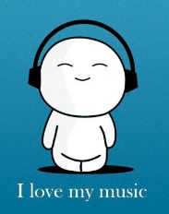
- THREE pieces (with the maximum combination of TWO activities: i.e. 2 on one instrument and 1 on another)
- UNPREPARED TEST

