Junior Certificate Music Exam 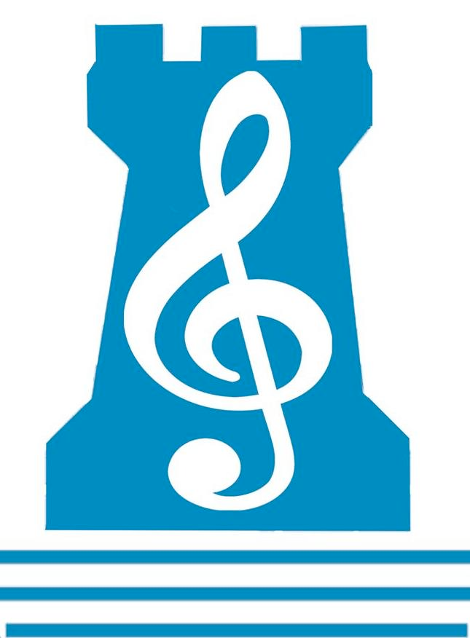
Wednesday 20th June 2018
Time: 9.30-11.30 am
Q1 SET A SONGS

♫ An Mhaighdean Mhara
♫ Little Sandman
♫ Kalinka
♫ Streets of Laredo
♫ 59th St. Bridge Song
♫ Wexford Carol
♫ Spring
♫ Summer is icumen in

Q2 SET A WORKS
♫ William Tell Overture ♫ Carmina Burana
- Water Music Hornpipe &Water Music Minuet

Q3 IRISH MUSIC
♫ Traditional & Non-Traditional Features
♫ Traditional & Non-Traditional Instruments
♫ Performers of those instruments
♫ Features of Sean-Nós Singing
♫ The Song Tradition
♫ Irish Dances (Jig, Reel, Hornpipe, Slip Jig)
♫ Collectors / Preservation of Irish Music
♫ Belfast Harp Festival, 1792
♫ The Harping Tradition
♫ Group Performance / Performers
♫ Development of Irish Music

Q4 DICTATION
♫ OL: Fill in missing Rhythm & Time Signature
♫ HL: Fill in missing Melody & Rhythm

Q5 CHOICE SONGS / WORKS (see list below)

Q6 TRIADS
♫ Chord Banks in Keys of Bb, F, C, G, D
♫ Key Signatures / Major & Minor Chords / Bass Clef notes

Q7 MELODY WRITING
♫ Create a 4-bar melody

Q8 BACKING CHORDS
♫ Chord Banks in all Keys/ Cadences / Good Chord Progressions / Major & Minor chords

Q10 GENERAL STUDY
- Write about THREE Musical Features of your Chosen Study-TWO pieces

Q5 CHOSEN SONGS and WORKS

SONGS:

CATEGORY TITLE:
Irish Folk Song
Folk Song from another country
Art Song
2-Part Song
From Musical
Oratorio
Ballads
Popular Song
Carols

WORKS:

CATEGORY TITLE:
Dance Movements
Symphony / Suite
Orchestrally Accompanied Instrumental
Orchestrally Accompanied Vocal
Illustrative, Film Music
Overtures / Preludes / Intermezzi

