2nd Year Higher Level Revision List for End of Year Exam
Algebra 1 Chapter 1 | You must be able to: | Date Revised
 | Simplify expressions
 | Remove brackets
 | Evaluating expressions
 | Solve linear equations
 | Solve problems using line equations
 | Solve inequalities

Factorising Chapter 2 | You must be able to: | Date Revised
 | Factorise with common factors
 | Factorise by grouping terms
 | Factorise the difference of two squares
 | Factorise quadratic equations
 | Using factors to simplify algebraic fractions

Quadratic equations Chapter 8 | You must be able to: | Date Revised
 | Solve quadratic equations using factors
Use the quadratic formula Page 20 in the tables book
. (Can only use in trinomials)
 | Solve word problems that become quadratic equations
 | Use graphs to solve quadratic equations
 | Form quadratic equations when given its roots.

Perimeter, Area and Volume | Chapter 6 page 85 - 114  Chapter 17 page 340 - 353  You must be able to | Date Revised
 | To find length of the perimeter and the area of the following figures: disc, triangle, rectangle, square, and figures made from combinations of these
Investigate the nets of rectangular solids
find the volume of rectangular solids and cylinders
Find the surface area of rectangular solids
Solve problems involving surface area of triangular base prisms (right angle, isosceles, equilateral), cylinders and cones
Solve problems involving curved surface area of cylinders, cones and spheres

Statistics  Chapter 5 page 72-83  Chapter 7 page 117-136  Chapter 13 page 247-273 | You must be able to:
You must be able to be able to identify the different types of Data
Categorical Data
Numerical Data
 | Find the mean mode and median and know whish one to use when
 | Find the range and interquartile range
 | Represent data using a variety of graphs stem and leaf, pie, bar chart, histogram

Coordinate geometry of the line  Chapt 11 page 204 - 231 | You must be able to;
 | Find the distance, midpoint and slope between two points
 | Find the equation of a line
 | Find the slope of a line when given its equation
 | Find parallel and perpendicular lines

Simultaneous Equations  Chapt 14 page 276-285 | You must be able to:
 | Solve simultaneous equations
 | Solve problems involving simultaneous equations

Geometry  Chapt 9 page 150 – 172  Chapt 16 page 310 - 331 | You must be able to:
 | Be able to identify different angles and triangles
 | Explain and answer problems on the theorem of Pythagoras
 | Be able to explain transversals and lines
 | Answer questions on triangles and circles

The best way to revise maths is to practice questions:
Projectmaths.ie has a student section useful to revise exam style questions
The Test yourself section of each chapter is also good
Some useful websites to help include
www.Purplemath.com
www.Mathsisfun.com
For the exam BE PREPARED: Pens, Pencils, Ruler, calculator and yoru tables book. GOOD LUCK!!!

Exam Practice:
Q1

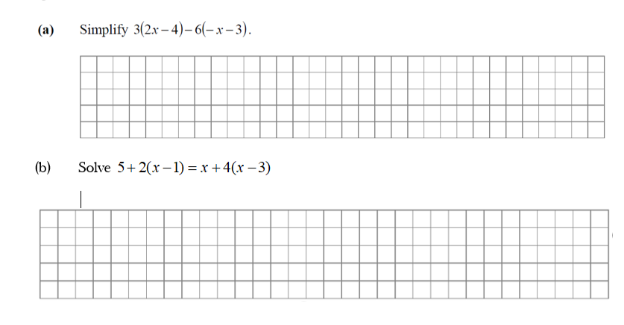
( c )
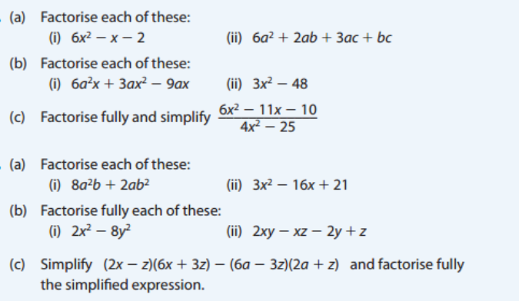

Q3
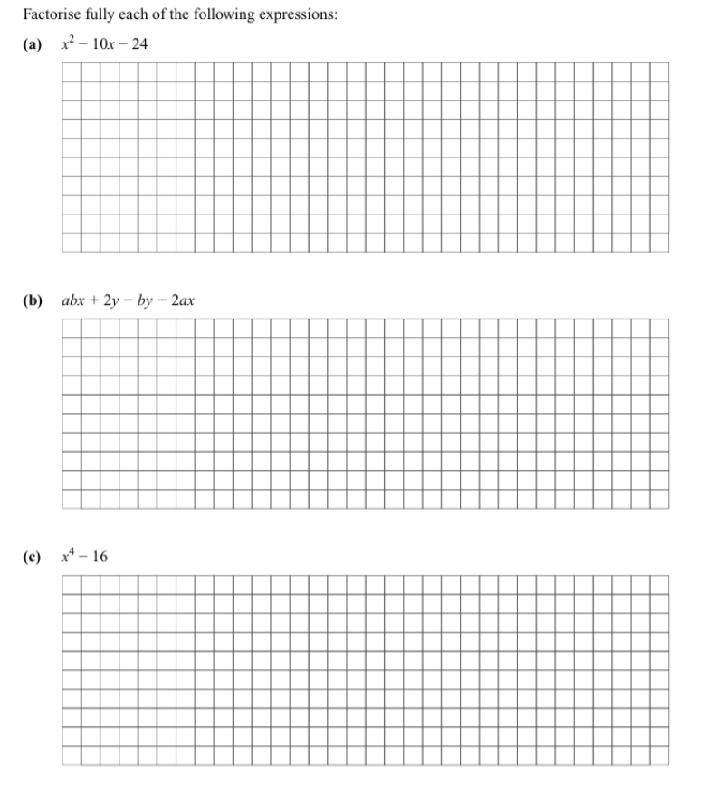

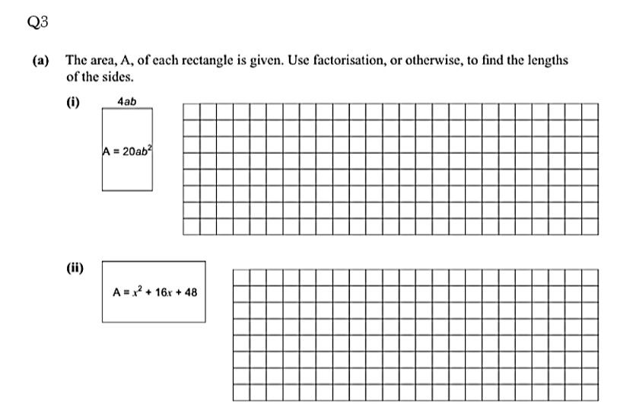
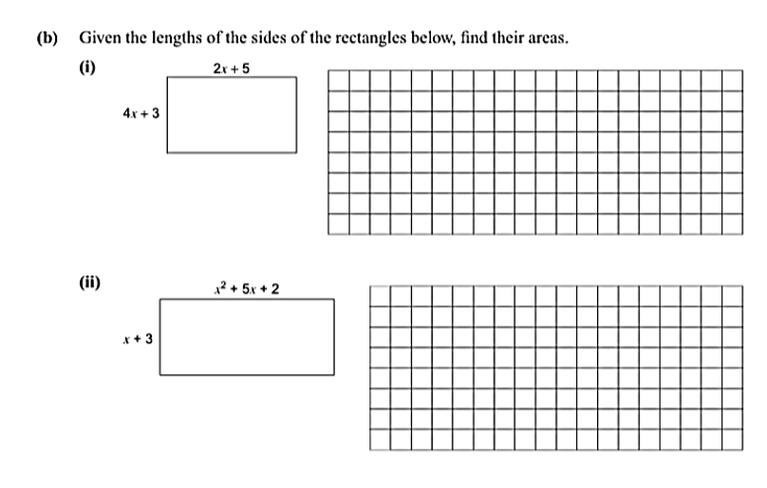

Q4
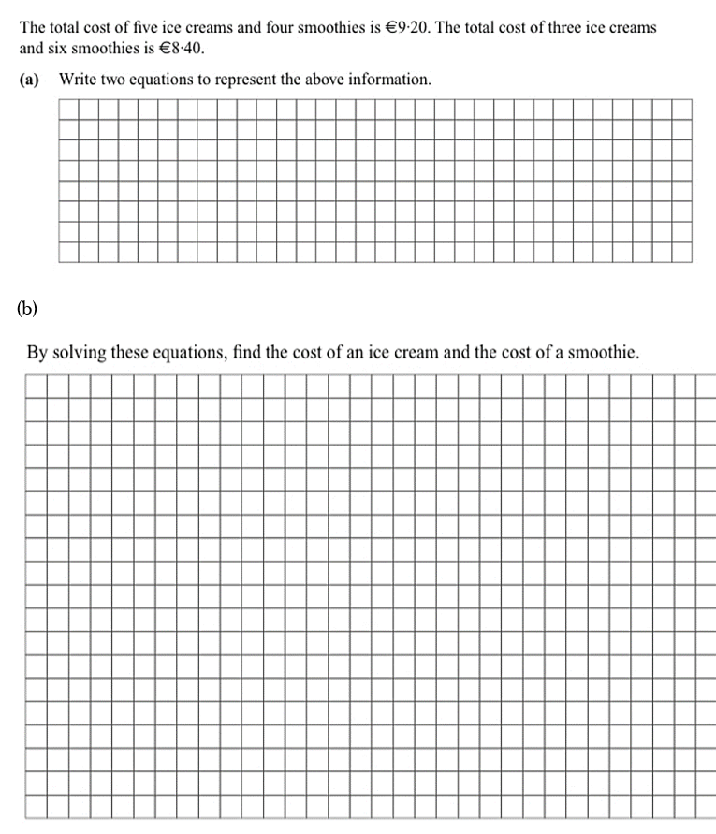

Q5
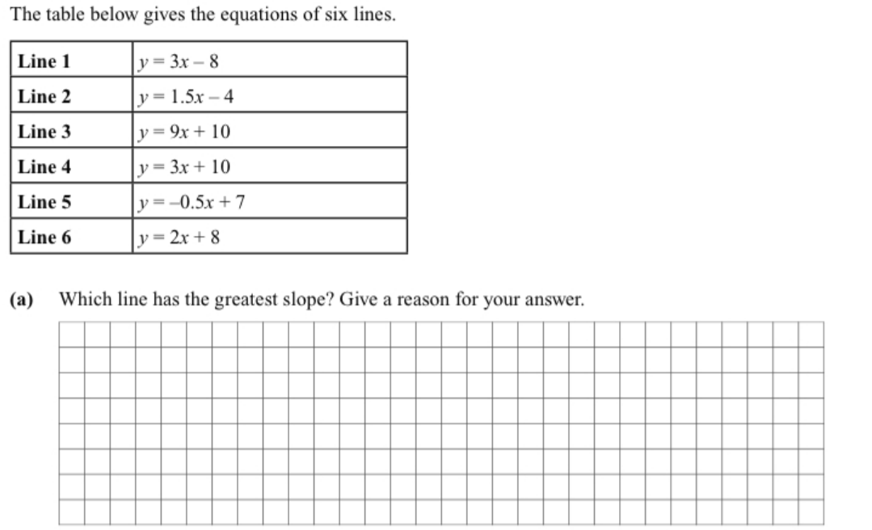
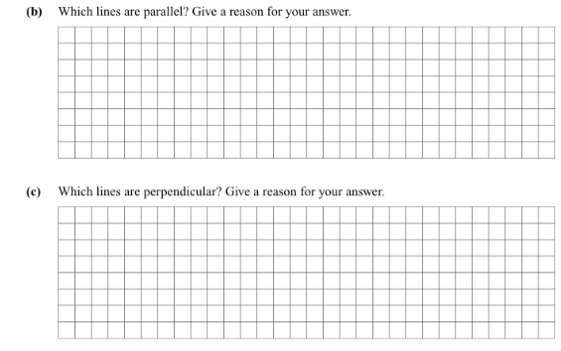

Q6
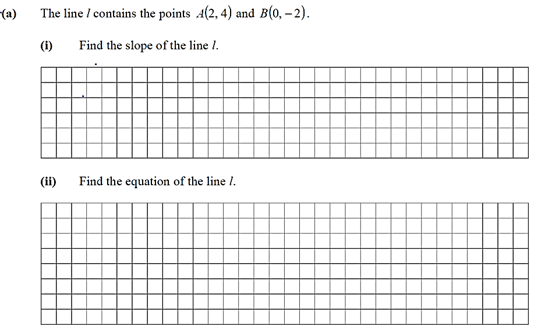
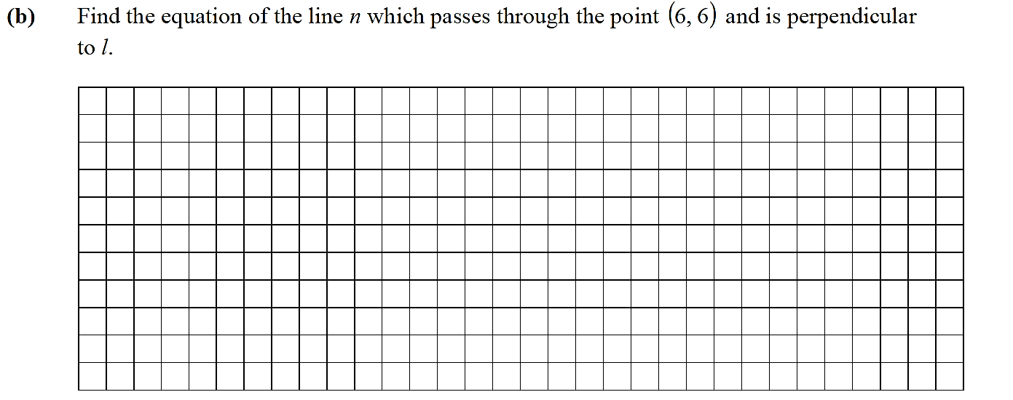

Q7
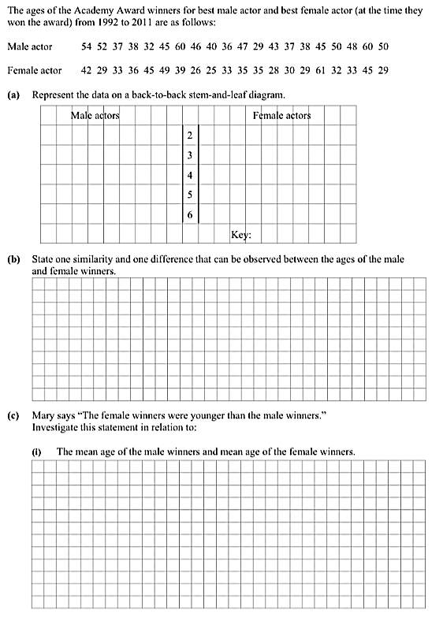

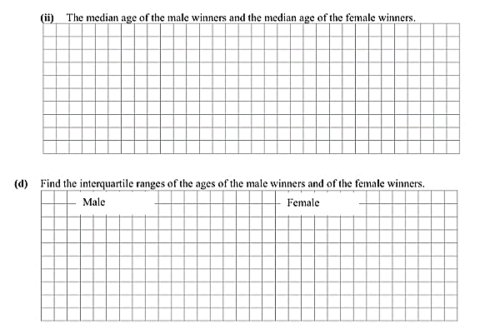
Q8
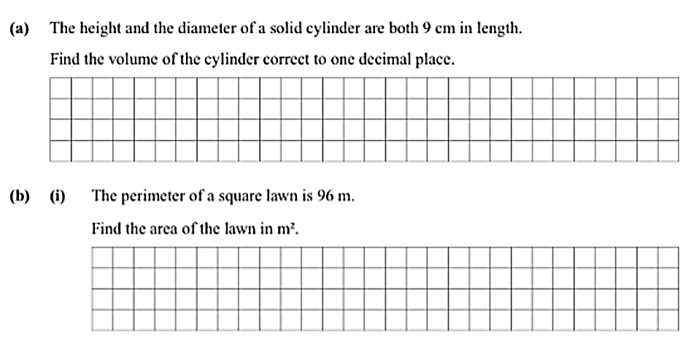

Q9
