Q1. 10 marks
$4\left(2x−3\right)=2\left(3x−5\right)$
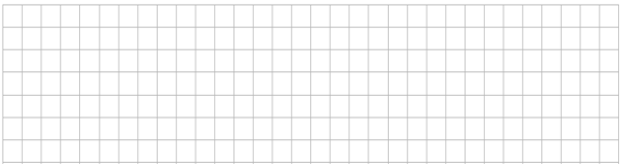
Q2. 15 marks
Express as a single fraction:
$\frac{3x−4}{6}$ - $\frac{2x+1}{3}$

Q3. 10 marks
Evaluate (i) $\sqrt{36}$ (ii) $6^{−2}$

Q4. 30 marks
(a) Solve the equation: $\frac{1}{2}\left(7x−2\right)+5=2x+7$


(b) Solve $2x^{2}−4x−3=0.$ Round your answer to two decimal places.

(c) Verify that $3−\sqrt{2}$ is a root (solution) of the equation $x^{2}+6x+7=$0

Q5. 10 marks
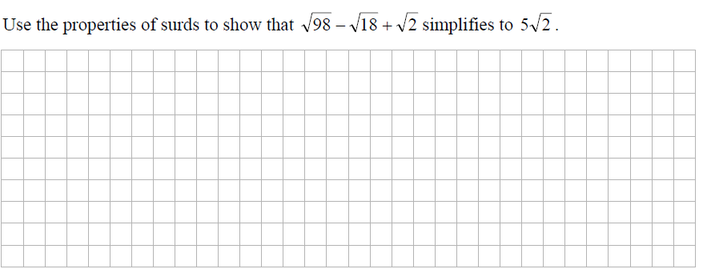

Q6 35 marks
(a).
$$y−2x=1$$
$$2y−3x=5$$

Q6 (b). The area of this rectangle is 24${cm}^{2}$ (3x – 4) cm
Find the length and width of the rectangle (x -1) cm

Q7 40 marks
(a). Find the value of the x in each of the following
$$3^{x+2}=81$$

Q7 (b). Solve for x and y
$x^{2}+y^{2}=10$
$x−y=4$

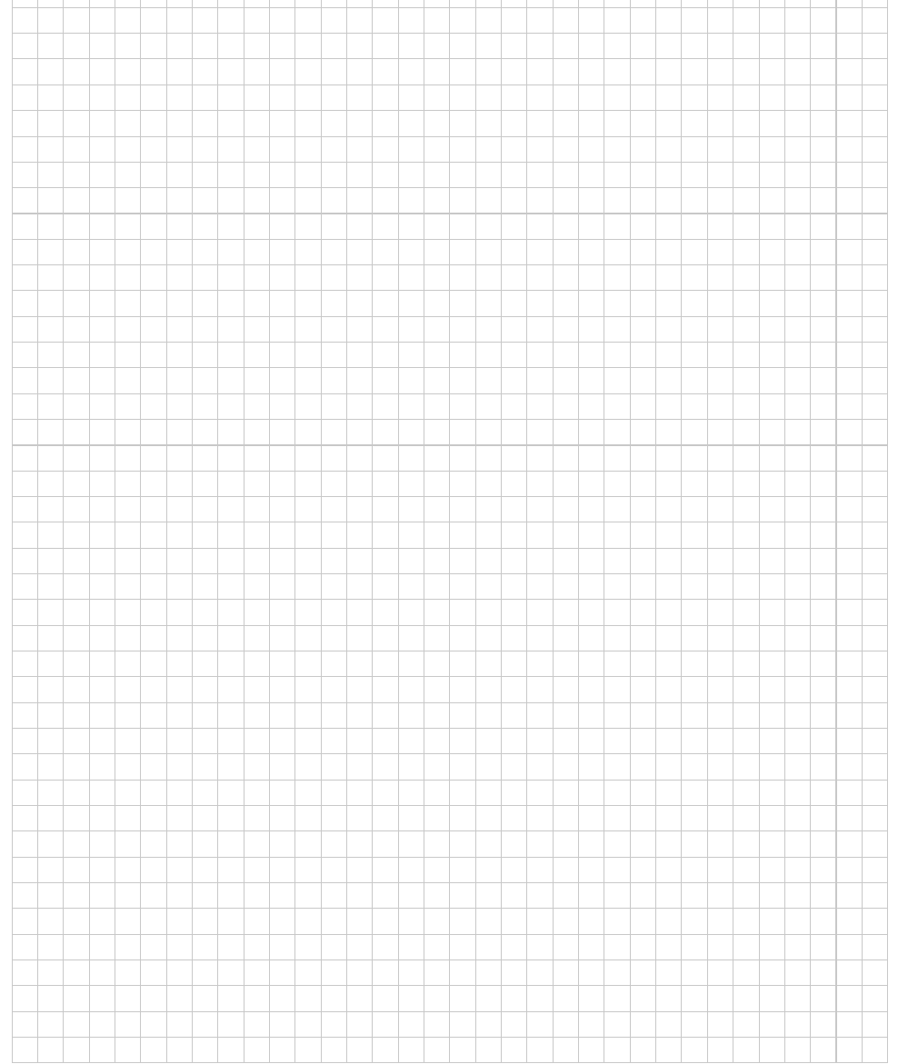

Q8. 30 marks
- Factorise: $x^{2}−10x+24$

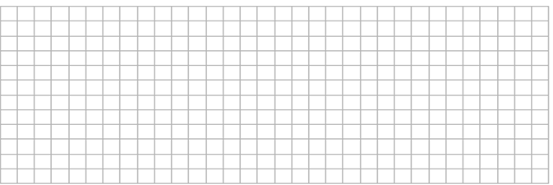

- Factorise: $81−p^{2}$

- Factorise: $x^{2}−8x$
Q9. 20 marks
Form quadratic equations with the following roots:

- 2, 4
- $−2,5$
Q10

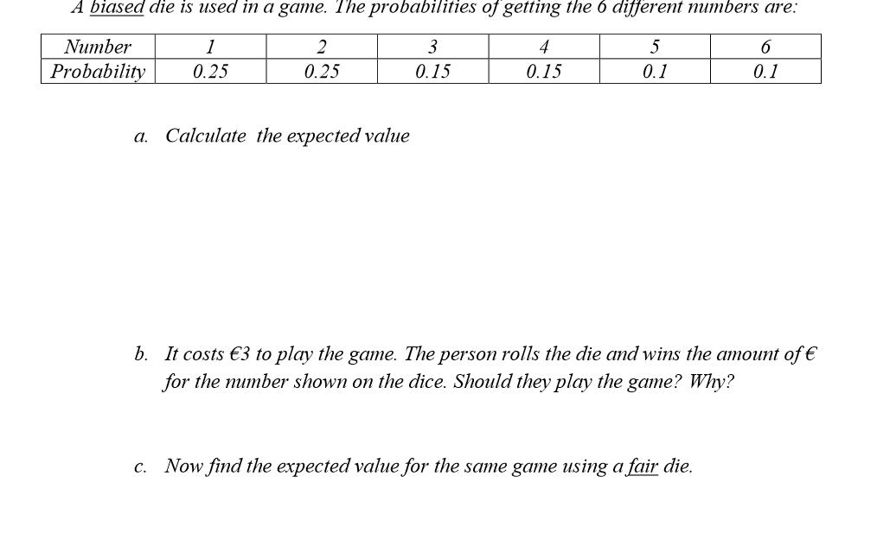

Q11
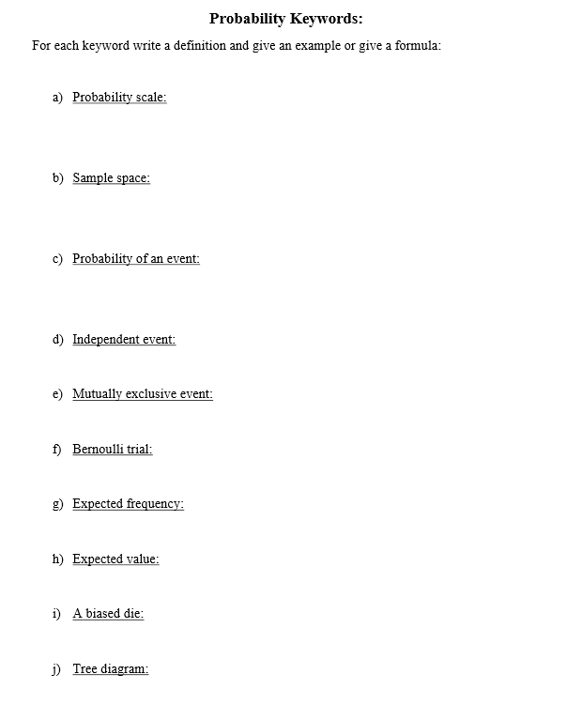

Q12
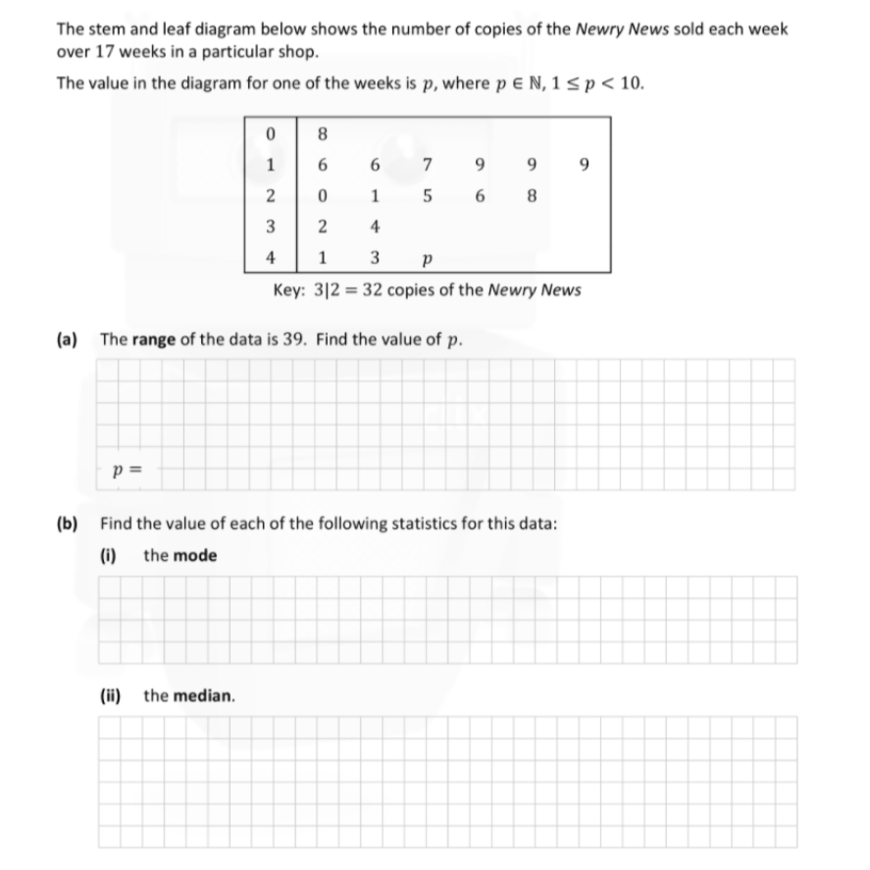

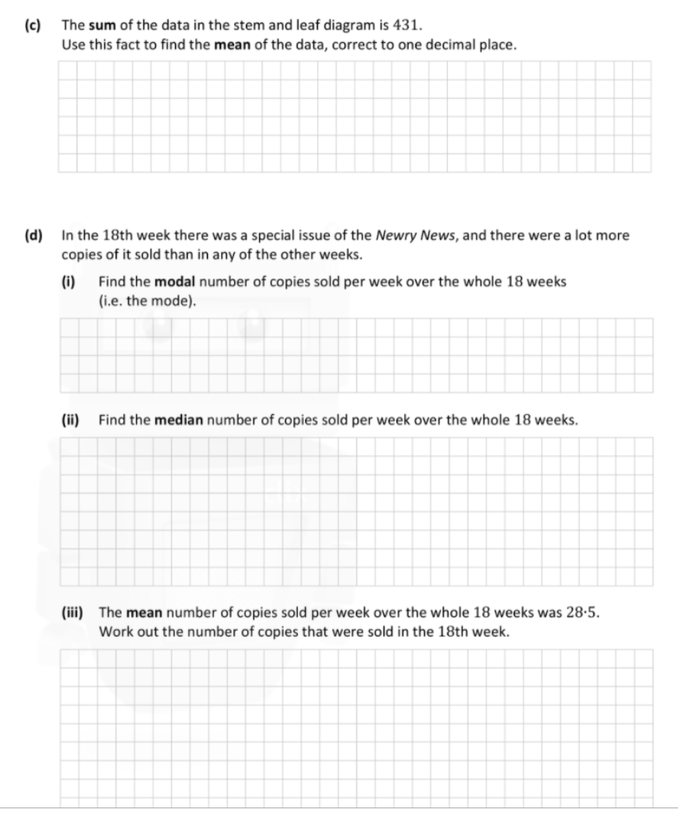

Q13

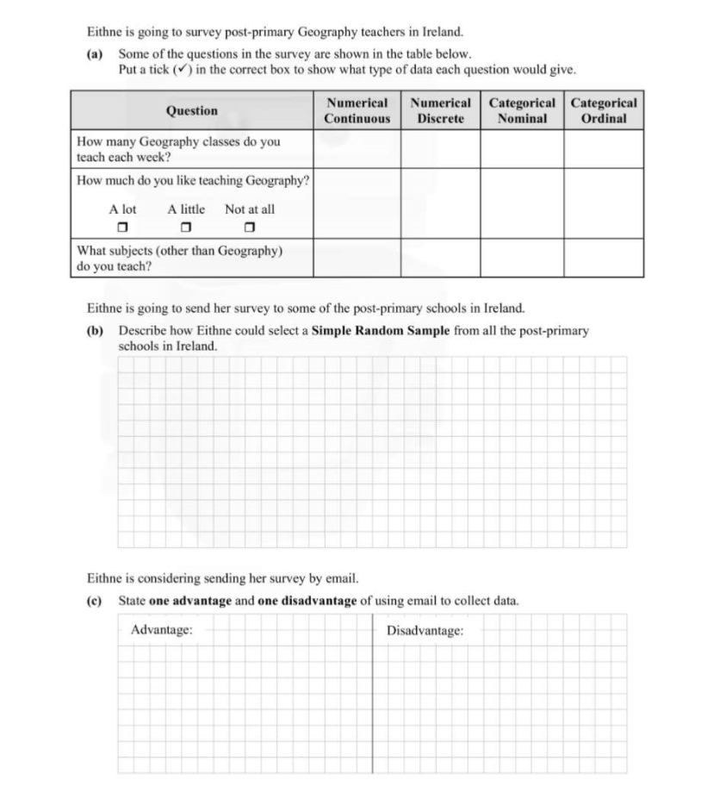

Q14
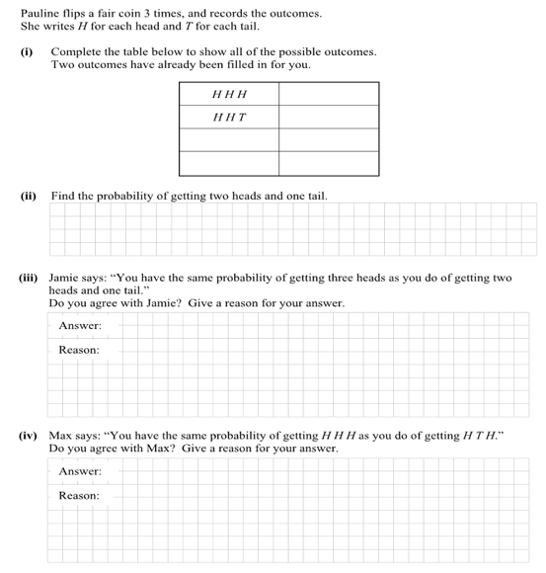

Q15
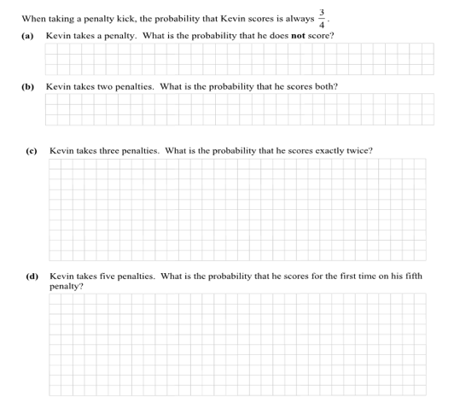

Q16

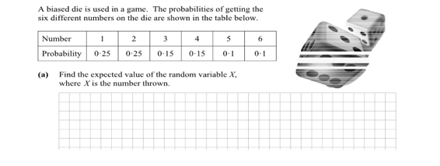

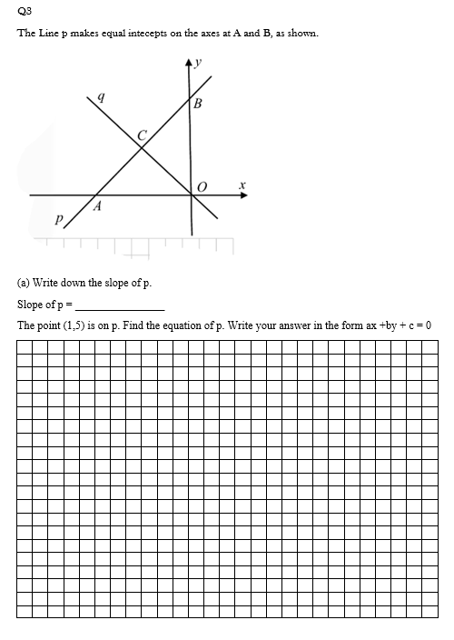

Q18
